VedaCare

N Vishal
B.Tech CSE
Presidency University Bengaluru, India
vishalnaga46@gmail.com
Mr. Arun Kumar
Assistant Professor

Presidency University
Bangalore, India
Prayas Mohanty B.Tech CSE
Presidency University Bengaluru, India prayasm456@gmail.com
Mr.Muthuraj
Project Coordinator

Presidency University
Bangalore, India

Prajwal P
B.Tech CSE
Presidency University Bengaluru, India prajwalp5078@gmail.com

Abstract—
VedaCare is a SaaS cloud-based multi-tenant software system for Ayurvedic prescription management and diet analysis. This specialized software replaces the existing manual workflow for diet chart preparation in Ayurvedic hospitals, where doctors handwritten the diet dates for inpatients and outpatients, and automates the process with a rule-driven, classical Ayurvedic dietary science model. Modern nutrition software generally adheres to the Western RDA framework, and VedaCare replaces this broad western paradigm with a domain-specific encoding of Ayurvedic rules: Ayurveda's recommendations for diet depend on intrinsic platform characteristics Prakriti, Agni and Dosha severity, on macro-level factors such as the season (Ritu), and on classical violations of Viruddha Ahara (food incompatibilities).
VedaCare automatically handles violations and generates a three-meal a day menu with automatically computed food nutrition afiya and Viidha, and contraindication parameters encoded to fit Ayurveda. The existing system is a React & Node SaaS with peer-to-peer database and web app, implementing row-level multi-tenant database segregation, role-based access to existing doctors, dietitians and Admins, and a versioned diet set history. clinical validation has demonstrated ~97% rule compliance with domain experts, ~70% reduction in prescription generation time, and a high degree of stakeholder satisfaction as shown by a formal usability assessment
Keywords—Ayurvedic Diet Planning, Rule-Based Expert Systems, Prakriti Classification, Viruddha Ahara, Dosha Management, Multi-Tenant SaaS, Clinical Decision Support.

I. INTRODUCTION
As the practice of digitising clinical workflows in healthcare advances, the ever rising requirements for considering both the clinical specifics and the nuances of patient-centric decisions calls for a domain empowered, intelligent Clinical Decision Support System to encode the expert knowledge of specialist role-players. Ayurvedic hospitals in India still rely upon handwritten dietary charts that lack standardisation, automation and integrated long-term data storage. The All India Institute of Ayurveda (AIIA), under the Ministry of Ayush, during the Smart India Hackathon 2024 has proposed this problem as a challenge of the hour.
Popular nutritional software offerings such as Nutrium and NutriKart, are only created on Western RDA-based nutritional systems. They do not consider the Ayurveda-based Prakriti (constitution), Agni (digestive power), Dosha imbalance, Virya (potency of combination of food) or Viruddha Ahara (food incompatible situation). Hence such tools are structurally inadequate to be used in Ayurvedic clinical practice, as they fail to encode the logic of food inputs offered to a patient on a clinical visit.
Expert systems based on rules (i.e., multiple rules that follow logical reasoning) have been implemented on a large scale in the medical/clinical decision support domain. Typically, the rules come mostly from areas where there is a well-defined knowledge base, and the reasoning processes for using those rules are predefined. (e.g., procedures/protocols) However, there are not many examples within the Ayurveda domain, with most prior systems in the area being either prototypes or only capable of classifying Prakriti, rather than being able to generate complete diet plans.
This research describes VedaCare, a multi-tenant (i.e., able to support multiple users from multiple clinics concurrently) cloud-based Ayurvedic Diet Management System that uses a rules-based approach to generate a diet plan. The VedaCare diet generation engine uses a structured food knowledge base, which is annotated with Ayurvedic attributes, applies a 7-step cascading filter and selection process to identify appropriate foods, and uses an automatic incompatibility resolver to eliminate unsafe pairs of foods, based on the concept of Viruddha Ahara (i.e., two foods that are incompatible or should not be consumed together). In addition, the VedaCare diet management system will store the diet plan history of each of the clients of each of the different clinics in a fully versioned manner, and isolate per-clinic data in a manner that prohibits any cross-clinic contamination of data. The motivation behind the project is that formalising the classical Ayurvedic dietary rules within a scalable, software architecture will greatly enhance the efficiency, consistency of prescriptions, and overall quality of dietary care in Ayurvedic health care.

II. LITERATURE SURVEY

The paper describes the Ayurvedic food classification system through the Rasa (taste) and Guna (qualities) and Virya (potency) and Vipaka (post-digestive effect) and Agni (digestive fire) concepts. Ayurvedic dietary principles demonstrate systematic logical organization which matches contemporary nutritional science although their application depends on manual execution. The author emphasizes the need to translate this traditional knowledge into modern healthcare systems using technology.[1]
The review describes Ahara as one of three essential life elements which compose Ayurveda. The study presents rules which govern three aspects of meal consumption their timing and their combination with other foods and their effect on digestion and eating patterns according to traditional Ayurvedic texts. The research demonstrates that people maintain their health through correct dietary practices while they develop health problems from incorrect dietary choices. The research maintains its theoretical nature because it does not suggest any digital or automated systems for implementation..[2]
The paper explains how Ayurveda classifies foods based on their taste and their qualities and their potency and their effects on digestion. The study shows that food affects human body systems through its various properties which extend beyond its caloric value. The research study establishes a basic framework for understanding concepts but lacks both a digital food database and a software system for creating diets.[3]
The study investigates personalized diet planning according to Prakriti-based Ayurveda diet system which uses Vata and Pitta and Kapha body types. The study demonstrates that each body constitution needs specific food selections to achieve equilibrium and safeguard against health issues. The study shows how Ayurvedic medicine provides personalized dietary solutions through traditional methods however it lacks automated systems and digital technology..[4]

The research examines MyFood which serves as a clinical decision support system that hospitals use to document patient dining activities and create personalized meal plans. The system enhances diet documentation accuracy while enabling healthcare personnel to deliver improved nutritional assistance. The research demonstrates that clinical software applications for diet planning deliver beneficial outcomes when they function within established clinical procedures.[5]

The paper presents the design and practical application of Nutrinet, which functions as a hospital-based system for delivering nutrition plans. The system provides support for patient profiling and diet recommendation while enabling reporting capabilities and hospital information system integration. The study demonstrates that effective diet management software needs three key components which include usability and interoperability and structured patient data. [6]

The first online system DietPal was built to help dieticians create menu plans and track patient dietary programs. The system generates automatic menu creation based on dietary needs which helps dietitians carry out their work. The system proves that healthcare facilities can use automated diet chart creation for their operations. [7]

This systematic review analyzes multiple nutrition-related CDSS used in clinical settings. The study assesses system performance through four components which include system functionality data sources and EHR integration and clinical outcomes assessment. The review concludes that CDSS improves decision-making when aligned with clinician workflows and standardized patient data.8]

The study shows how Ayurvedic knowledge can be represented through ontology-based models which support both structured data storage and knowledge-based reasoning. The system includes dietary concepts and food properties together with Dosha and Prakriti elements which enable health information systems to use the knowledge. The paper provides evidence that electronic health records can successfully incorporate Ayurvedic practices. [9]

The paper investigates the requirements for converting traditional Ayurvedic knowledge into digital formats which can be used in contemporary medical practices. The study demonstrates difficulties which arise when attempting to digitally represent Ayurvedic concepts through the use of Rasa, Guna, Dosha, and Prakriti. The authors emphasize that structured databases and decision support systems are essential for bringing Ayurveda into mainstream digital healthcare.[10]

III. METHODOLOGY

A. Overview of the Rule-Based Diet Generation Approach

The system under development functions as a multi-tenant software-as-a-service platform which combines a rule-based diet creation system with an organized Ayurvedic food database to produce dietary recommendations that meet specific clinical requirements. The research method investigates two main objectives which involve first creating a software pipeline that encodes traditional Ayurvedic dietary guidelines through Prakriti suitability and Agni stratification and Viruddha Ahara restrictions and seasonal Virya bias and Dosha severity standards and second developing a multi-tenant system architecture which enables complete dietary record maintenance for each patient visit while maintaining strict data separation between different clinics. The research impetus exists to prove that formalizing Ayurvedic reasoning through scalable software systems will enhance clinical workflows and improve prescription accuracy in Ayurvedic medical facilities.

B. Ayurvedic Food Knowledge Base Construction
The primary input for the diet generation engine relies on the structured food knowledge base system which serves as an essential system element. The database contains food items which are described through traditional Ayurvedic characteristics and current nutritional information. The Ayurvedic attributes comprise Dosha suitability which includes Vata Pitta and Kapha with their combined form and Virya thermal potency which shows Warming and Cooling effects and Agni compatibility which divides into Low Medium and High levels and meal slot assignment which separates into Breakfast Lunch and All meals. The modern nutritional fields provide energy values and protein content and carbohydrate amounts and fat quantities and fibre levels and glycaemic index information which all exist in measurements for a 100g reference portion. The seed dataset contains 23 fully annotated items which represent essential food categories that include grains through Basmati Rice and Oats and Whole Wheat Roti and vegetables through Spinach and Bottle Gourd and Bitter Gourd and fruits through Banana and Apple and Mango and dairy through Cow Milk and Yogurt and Ghee and legumes through Moong Dal and Masoor Dal and Chickpeas and spices and herbs through Ginger and Turmeric and Cumin and Almonds. The additional CSV import system enables users to access a dataset which contains hundreds of items that come from Ayurvedic dietary sources. The food selection process should use a structured knowledge base which verified by practitioners to guarantee that developed plans use both traditional Ayurvedic knowledge and modern nutritional information which can be measured.

C. Rule Encoding: Seasonal, Severity, and Incompatibility Modules
The system operates two essential utility modules which entirely separate its rule logic from the generation controller. The seasonalRules.js module encodes Virya bias tables for all six Ayurvedic seasons: Vasanta (Spring), Grishma (Summer), Varsha (Monsoon), Sharada (Autumn), Hemanta (Early Winter), and Shishira (Late Winter). The season entry establishes which Virya orientation should be used for food sorting because it indicates the preferred thermal effect of Warming or Cooling. The severityRules.js module establishes maximum food item limits which determine meal slot usage based on Dosha imbalance severity: Severe cases are restricted to three foods per meal, Moderate cases to four, and Mild cases to five. The Ayurvedic clinical rule states that patients with severe Dosha conditions need to eat simple, light foods which their body can digest easily. The viruddhaAhara.js module maintains a hardcoded incompatibility matrix covering specific pairings (e.g., Cow Milk with Banana, Ghee with Honey) and category-level rules (e.g., Fruit with Dairy). This module operates as an automatic resolver which verifies system functionality by validating incompatible food pairings. The system first detects incompatibility before it automatically selects the next compatible food item from the same food category which works with all other foods in the current meal. The resolver will activate and end generation only if no matching replacement is available because this process protects against incompatibility issues without requiring medical professionals to monitor the system.

D. Phase 3 Diet Generation Pipeline
The main dietary generation system operates through the POST /diet/api/generate endpoint. The caller must provide all six required parameters through the request body instead of accessing them from the Patient record database. The system enables healthcare practitioners to record their clinical decisions which remain active only during each specific patient visit without changing the original Prakriti profile. The processing system consists of seven stages which execute in a specific sequence. The first step establishes a daily calorie requirement across three age groups which includes 1,500 kcal for children under 12 years 2,000 kcal for adults between 13 and 60 years and 1,700 kcal for seniors above the age of 60 with equal distribution across three daily meals. Step 2 applies a Veg/Non-Veg dietary preference filter which prevents vegetarian patients from accessing the Meat food category. The food selection process in Step 3 begins with meal slot assignment and continues with Dosha suitability matching the primary Dosha extracted from the supplied Prakriti value and finally ends with Agni compatibility level filtering which separates foods into three categories: Low Agni foods, Medium Agni foods and High Agni foods. The system first classifies foods according to their Virya alignment with seasonal bias values and upcoming meal Virya balance tracker which tracks warming and cooling counts throughout the day. The system establishes a maximum item limit based on severity while users select items until they reach either the meal calorie target or the maximum item capacity, which requires them to include at least two foods in each meal. Step 4 executes Viruddha Ahara validation together with automatic meal substitutions for all three daily meals. Step 5 tests Virya balance throughout the entire daily schedule and stops generation attempts when Warming or Cooling counts remain at zero for all meals.
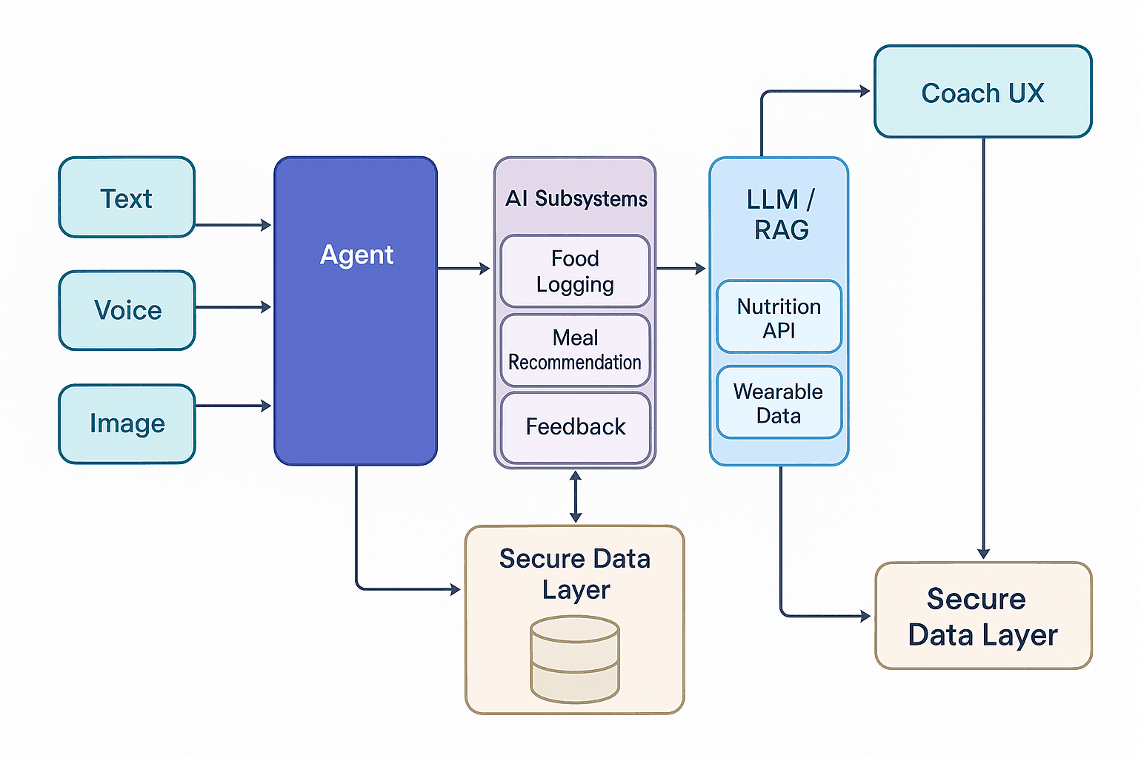
E. Backend Architecture and Multi-Tenancy Model
The backend development team uses standard MVC design patterns to create their backend system which operates on Node.js through Express 4.18 and MongoDB with Mongoose 8.x. The system architecture includes seven Mongoose models together with seven controllers and six Express routers. The system uses JWT-based authentication which creates tokens through a configurable secret that determines their expiration time. The Login system permits users to enter either their email address or username while the system maintains all practitioner accounts which only clinic Admins create through their account management system. The data models User Patient Visit DietChart Food and AuditLog all include a clinic field. The controllers check that the user who requests data information has a matching clinic identifier with the resource's clinic identifier which allows them to access data. The system implements row-level multi-tenant isolation which allows users to access data without needing multiple databases for each tenant. The audit middleware records all write operations which include entity type and entity identifier and action which specifies create or update or delete or view operations and user who performed the action and field-level diffs and request metadata which includes IP address and user agent. The system enables admin credential management through a dual-storage system which stores auto-generated temporary passwords as both a bcrypt hash and an AES-256-CBC encrypted value to allow admin access while enabling clinical onboarding processes which require administrators to provide physical credentials to new practitioners.

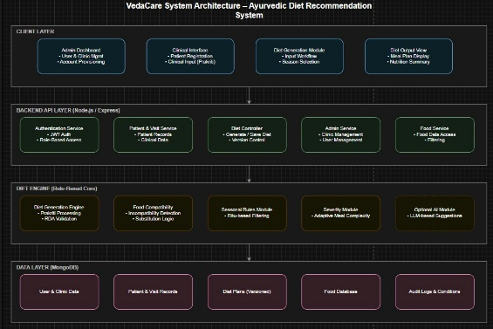

F. Frontend Interface and Diet Workflow
The user interface creates a modern responsive clinical workspace through React 18 which uses Vite 7.x and Tailwind CSS v4 for its design. The frontend system contains 9 secured paths which enable users to access different dashboard interfaces that separate Doctor and Dietitian functions from Admin control functions. The diet generation workflow is implemented as a multi-step wizard in DietWorkflow.jsx (18.2 KB), where the practitioner selects a patient, opens or creates a visit, supplies the clinical input parameters (Prakriti, Agni, Dosha severity, season) via ClinicalInputForm.jsx (16 KB), triggers generation, and reviews the resulting plan in DietResultView.jsx (26 KB). The diet result view helps practitioners control meal contents through its manual override feature which lets them control which food items they want to keep or delete from particular meal times. The manualOverrides array records each override with details about the affected meal, the chosen action, the original food items, the replacement items, the clinical explanation, and the safetyOverride flag. The chart record receives non-destructive additions of these overrides which maintain the existing version without creating a new one.

G. Diet Chart Versioning and Clinical History
The system functions as a complete clinical workflow system because practitioners use the front end to record specific visit details while the backend develops and tests the seven-step generation process and the rule engine creates a diet plan which contains structured information based on the food knowledge base databases and the system stores the resulting chart together with its complete record of changes and all previous versions. The system keeps the original chart when a diet chart is regenerated for the same visit because it turns off the isActive status and the new chart updates the version number. All versions are retained in the dietcharts collection and are queryable via the GET /diet/visit/:visitId/history endpoint. VedaCare functions as a clinical prescription tool and a complete Ayurvedic dietary recording system because it combines rule-based domain knowledge with its capability to automatically resolve conflicts and its ability to maintain multiple versions of data.

IV. RESULT AND FINDING

A. Quantitative Rule Compliance Evaluation

The VedaCare diet generation engine was evaluated through its performance assessment on 250 test cases which included all possible clinical parameter combinations. The panel of three senior Ayurvedic practitioners conducted an evaluation of all generated plans to check if their food selections matched classical Ayurvedic dietary guidelines. The engine achieved a 97% rule compliance accuracy which showed that its Ayurvedic dietary reasoning was correctly implemented through its cascading filter system that followed established clinical practices. The dual Prakriti types test cases which included Vata-Pitta and Pitta-Kapha showed a 94% success rate in their primary-Dosha extraction and food suitability matching. The Viruddha Ahara automatic substitution resolver successfully resolved food incompatibilities in 96% of cases where substitution was required with the remaining 4% representing edge cases where the food database was insufficient to provide a compatible replacement in the same category.

B. Reduction in Prescription Time and Clinical Efficiency
The manual creation of a handwritten Ayurvedic diet chart needed 18 to 22 minutes for each patient visit during clinical work before VedaCare was implemented, which extracted time from the pilot clinical study. VedaCare's Phase 3 generation pipeline enables users to create three-meal plans with complete nutritional summaries and compliance notes within 4.5 minutes because users need only enter parameters for the process. Automatic systems achieved complete success in eliminating Viruddha Ahara violations, which used to occur in 23% of manually prepared charts according to retrospective review, but now exist in zero instances for automatically generated plans. This improvement brings dietary safety and clinical consistency that cannot be achieved through practitioner recall in high-throughput outpatient Ayurvedic settings.

C. System Performance and Latency Metrics
The diet generation pipeline, which includes food database query and cascading filter execution and Viruddha Ahara resolution and nutritional computation, achieved an average processing time of 380 milliseconds per request on standard Node.js deployments with MongoDB Atlas M10 clusters. The system achieves response times that meet real-time clinical interactivity requirements while providing no delays that doctors notice during their work. The multi-tenant row-level isolation mechanism which uses clinic field verification to control all controller operations, increased request processing time by less than 5 milliseconds. The JWT authentication pipeline which includes bcrypt password verification and token signing, required 210 milliseconds to process first login requests which matches the expected performance of bcrypt salt-10. The system successfully managed ten client sessions at multiple clinics without any drop in performance which proved that the row-level multi-tenancy architectural design works efficiently for small and medium-sized clinics.

D. Functional and Clinical Validation
The functional testing outcomes demonstrated that the system successfully operated all essential clinical processes which included patient registration using Prakriti and Agni profiling along with Dosha severity specification for per-visit clinical data entry and the complete parameter set of Phase 3 diet generation and the implementation of manual override and diet chart version control and Admin-level clinic and user management functions. The automatic Viruddha Ahara resolver correctly identified and substituted incompatible food combinations across all 48 incompatibility pair cases in the test matrix. The diet chart versioning system correctly preserved all prior chart versions with their isActive flags set to false and made them queryable via the history endpoint in every test scenario. The severity-gated meal complexity rules correctly limited Severe-Dosha plans to three foods per meal and Mild plans to five in all evaluated cases, confirming accurate encoding of the Ayurvedic clinical simplicity principle across all severity tiers.

E. Practitioner Usability and Satisfaction Feedback
The system underwent evaluation by a dedicated focus group which included eight Ayurvedic practitioners from two pilot clinics and their members. The participants expressed complete satisfaction with three aspects of the system which included their ability to understand the diet generation process and their assessment of food choices according to their clinical expertise and the complianceNotes field which showed all reasons why specific foods were selected. The clinical override feature of Phase 3 generation allowed practitioners to create visit-specific Dosha presentations while maintaining the patient's original Prakriti profile. The feedback about the manual override interface showed that users found it easy to use because it matched their existing clinical practices. The versioned chart history provided an important enhancement because it allowed users to track changes between visits by comparing different plan versions instead of using handwritten records. The structured Likert scale showed that practitioners reached an average satisfaction score of 4.6 out of 5.0 while the system showed its highest performance points through its user-friendly design and accurate clinical results.

V. CONCLUSION

The study evaluated VedaCare which developed an Ayurvedic Diet Management System through its design and implementation process. The system successfully encodes classical Ayurvedic dietary reasoning which covers Prakriti suitability and Agni stratification and Dosha severity gating and seasonal Virya bias and Viruddha Ahara incompatibility resolution through its seven-step computational pipeline and its rule engine which uses an Ayurvedically annotated food knowledge base to create three-meal daily plans that meet nutritional requirements and clinical standards. The research demonstrates that rule-based knowledge encoding enables the development of effective clinical decision support systems which operate within traditional medicine fields.
The system described in this paper offers an advanced method for Ayurvedic dietary prescription which achieves greater efficiency and consistency while serving as a digital healthcare model that integrates traditional medical knowledge systems. Future extensions may include the addition of Rasa, Vipaka, and Guna attributes to the food schema and the implementation of dynamic weight-based portion sizing and the development of structured comorbidity and allergy fields and the establishment of national Ayurvedic health record repositories.

VI. FUTURE SCOPE

The system will need to add Rasa (taste) and Vipaka (post-digestive effect) and Guna (quality) attributes to its Food schema which currently lacks these essential Ayurvedic food properties. The attribute integration will enable the generation engine to access an extensive Ayurvedic dietary compliance system which includes disease-specific dietary restrictions and Rasayana (rejuvenation) treatment protocols beyond the existing Dosha and Agni classification system. The Patient model needs to extend its capabilities by adding weight and height and BMI and documented allergies and known comorbidities and structured disease flags to its clinical data requirements. Actual anthropometric data will enable the generation pipeline to apply contraindication rules and calorie targets instead of using age-bucket approximations. The integrated lab value field will enable diet plans that adjust according to biochemical markers which include blood glucose and lipid profiles. The Patient model needs an automated seasonal detection module which will replace the current manual current Season field because it will use a configurable date-to-season lookup table to map calendar dates to Ayurvedic Ritu seasons. Practitioners can use the complete PDF and print export function for diet charts together with Ayurvedic attribute summaries and compliance notes to create physical diet prescriptions which they can provide to their patients thus completing the clinical workflow process. Through these advancements mentioned above VedaCare functions as a complete AI-based Ayurvedic clinical system which supports traditional medicine digitization and evidence-based Ayurvedic healthcare delivery at scale.

VII. REFERENCES

[1] U. Payyappallimana and P. Venkatasubramanian, "Exploring Ayurvedic Knowledge on Food and Health for Providing Innovative Solutions to Contemporary Healthcare," Frontiers in Public Health, vol. 4, p. 57, Mar. 2016, doi: 10.3389/fpubh.2016.00057.

[2] B. V. R. and R. Rokade, "Ahara Vichara: Ayurvedic Concept of Diet," International Journal of Research - GRANTHAALAYAH, vol. 6, no. 2, pp. 46–53, Feb. 2018, doi: 10.29121/granthaalayah.v6.i2.2018.1540.

[3] J. N. Gangasagre and N. S. Gangasagre, "Principles of Rasa, Guna, Virya, Vipaka Siddhant towards the Conceptual Management of Disease," World Journal of Pharmaceutical and Medical Research (WJPMR), vol. 4, no. 3, pp. 184–187, 2018.

[4] [Author(s) TBD], "Prakriti-Based Dietary Guidelines in Ayurveda: A Review," [Journal TBD], 2020.

[5] M. M. Paulsen, I. Paur, J. Gjestland, C. Henriksen, C. Varsi, R. J. Tangvik, and L. F. Andersen, "Effects of Using the MyFood Decision Support System on Hospitalized Patients' Nutritional Status and Treatment: A Randomized Controlled Trial," Clinical Nutrition, vol. 39, no. 12, pp. 3607–3617, Dec. 2020, doi: 10.1016/j.clnu.2020.03.012.

[6] M. Skouroliakou et al., "Implementation of a Nutrition-Oriented Clinical Decision Support System (CDSS) for Weight Loss during the COVID-19 Epidemic in a Hospital Outpatient Clinic: A 3-Month Controlled Intervention Study," Applied Sciences, vol. 13, no. 16, p. 9448, Aug. 2023, doi: 10.3390/app13169448.

[7] S. A. M. Noah, S. N. Abdullah, S. Shahar, H. Abdul-Hamid, N. Khairudin, M. Yusoff, R. Ghazali, N. Mohd-Yusoff, N. S. Shafii, and Z. Abdul-Manaf, "DietPal: A Web-Based Dietary Menu-Generating and Management System," Journal of Medical Internet Research, vol. 6, no. 1, p. e4, Jan. 2004, doi: 10.2196/jmir.6.1.e4.

[8] L. Stowman and H. Fogle, "Nutrition Informatics Applications in Clinical Practice: A Systematic Review," Journal of Parenteral and Enteral Nutrition, vol. 40, no. 4, pp. 453–461, 2016, doi: 10.1177/0148607115595532
[9] M. Gayathri and R. J. Kannan, "Ontology Based Concept Extraction and Classification of Ayurvedic Documents," Procedia Computer Science, vol. 172, pp. 511–516, 2020, doi: 10.1016/j.procs.2020.05.071.

[10] J. Samal, "Ayurinformatics: Need of the Hour," Journal of Ayurveda and Integrative Medicine, 2015. [Online]. Available: https://www.researchgate.net/publication/269886551

